**Assignment 3**

**Channel Capacity and Mutual Information**

The current assignment is concerned with the limits of wireless communication and the statistical quantities that determine those limits.

**AWGN Capacity**

The capacity of a non-fading wireless channel of bandwidth W is

$$C=W\log_{2}(1+SNR)$$

where SNR is the signal-to-noise-ratio.

The spectral efficiency is the capacity per Hz of bandwidth $C1=C/W$

Plot the AWGN spectral efficiency for for a range of SNR = {−6, .., 20} dB is shown below.

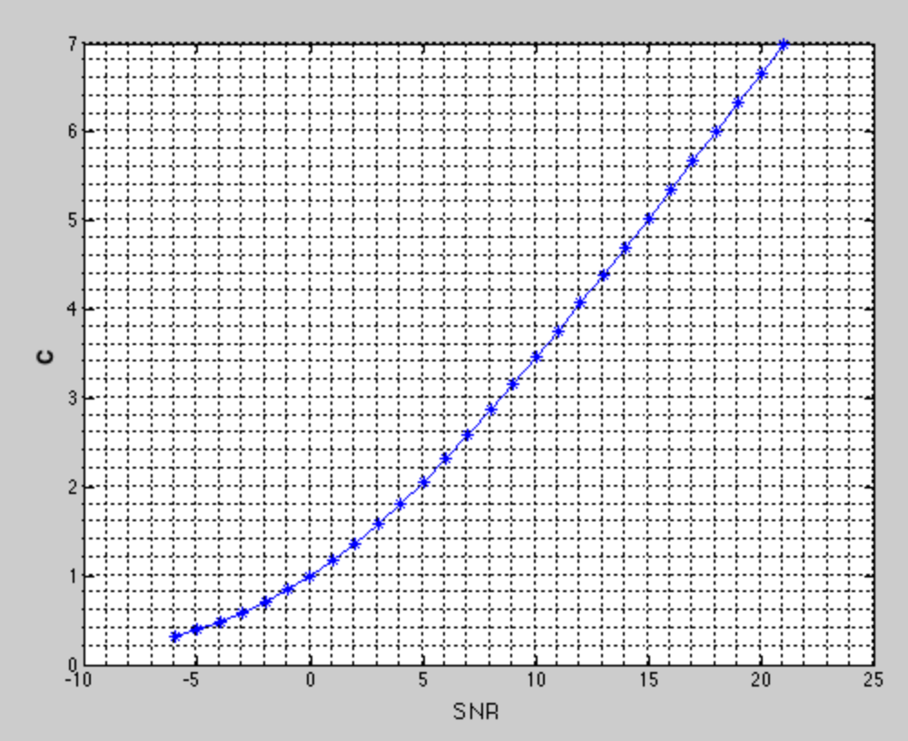

Pic.1 Spectral efficiency

**Ergodic Capacity of a Fading Channel**

Communication system with a Rayleigh fading channel with the following inputoutput relation is given.

$$y=hs+n$$

where n : CN (0, σ2 ), and the transmitted signal power E {s} = 1. The channel coefficient h is chosen according to a complex-normal distribution, i.e., n : CN (0,1) with variance one.

Thus $h=\sqrt{2}(i+jl)$, where $l∈(0,1)$

In this task bandwith W = 1

Spectral efficiency for a given realization of h can be found as

$$C=W\log_{2}(1+abs\left(h\right)SNR)$$

As W= 1 then C = C1 in this case. The average/ergodic capacity Eh {C(h)} of the fading channel by means of Monte-Carlo simulations to evaluate the expectation: $E\left\{C\left(h\right)\right\}=average\left(C1\right)=1,29∙{10 }^{-5}$

Due to the dependence on the random channel realization, the capacity C1 (W = 1) is a also random variable. The empirical cumulative distribution function (eCDF) of C1 (W = 1) is shown below.

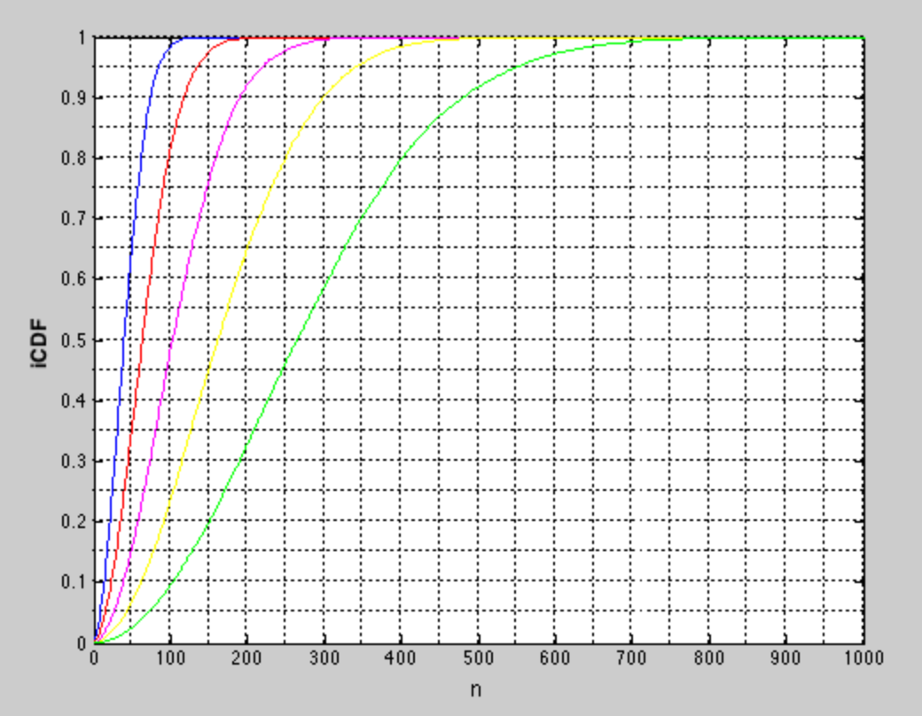

Pic.2 Empirical cumulative distribution function

bleu – SNR = 2

red – SNR = 4

pink – SNR = 6

yellow – SNR =8

grin – SNR = 10

**Mutual Information**

Communication system is shown in the figure below:

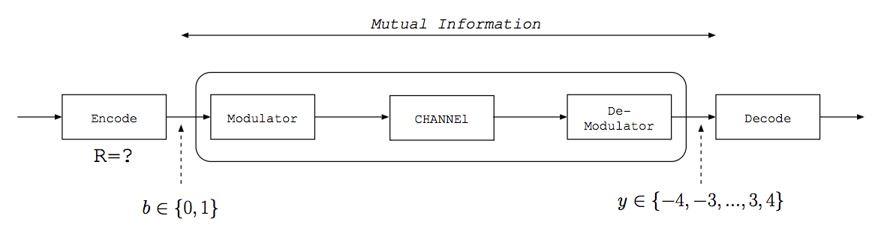

It comprises a channel en-/de-coder, a modulator/de-modulator, and the channel. A few samples from the input of the modulator and the corresponding symbols from the output of the de-modulator are known as an example. Modulator accepts binary symbols b ∈ {0, 1} and outputs symbols y ∈ {−4, ..., +4}

Task - to select the rate of a channel code that allows for reliable transmittion.

Samples of y (output) and b (input) data are given.

Mutual information can be found as

$$I(x,y)= \sum_{i,j}{p_{x,y}\left(i,j\right)log\frac{p_{x,y}\left(i,j\right)}{p_{x}(i)p_{y}(j)}}$$

Thus according to given samples y and b $p_{x}(i)$, $p_{y}(j)$, $p_{x,y}\left(i,j\right)$ were found.

Plot that shows the joint probability density and probability density of y and b are shown below.

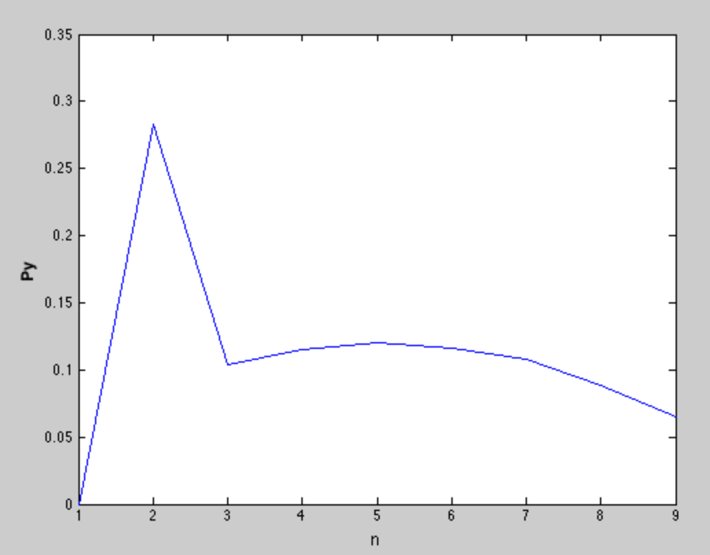

Pic. Probability density of y

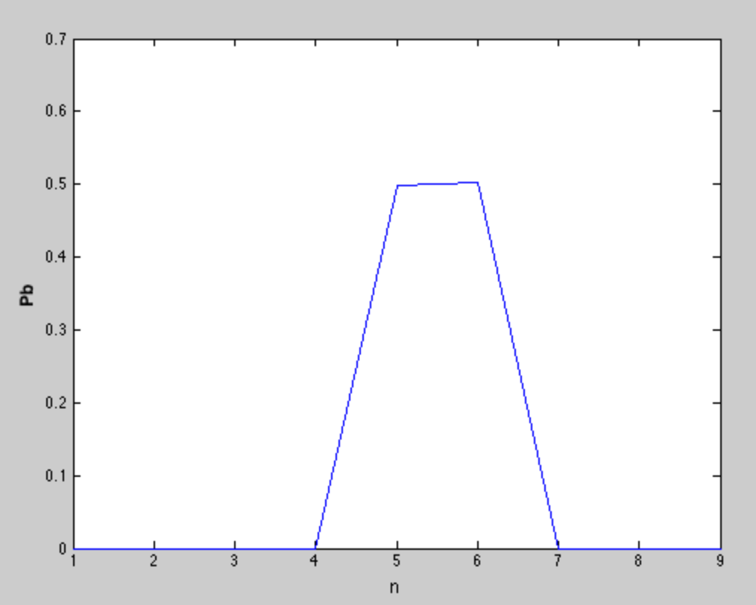

Pic. Probability density of b

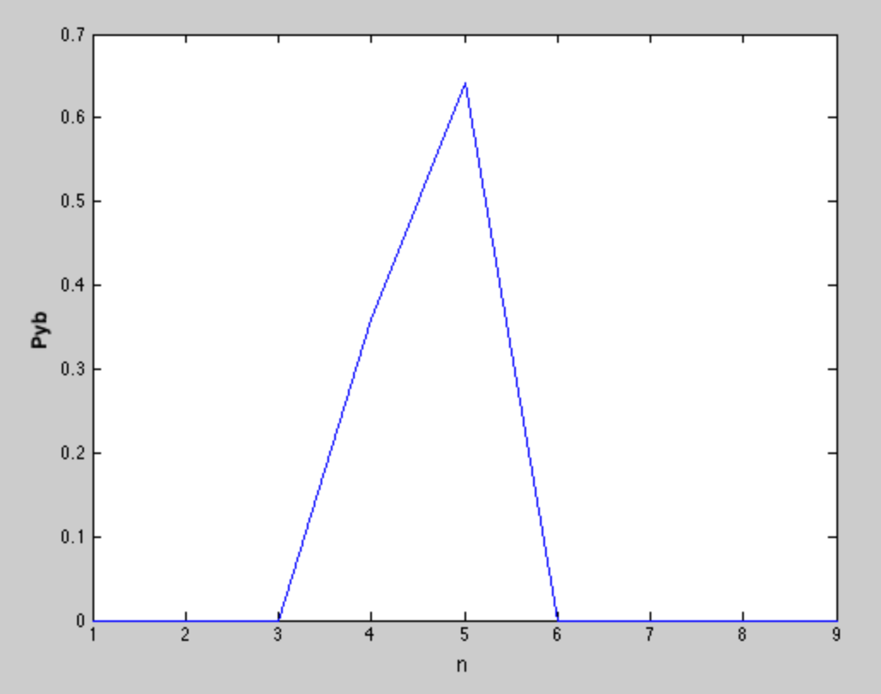

Pic. Joint probability density of y

Calculations were done in Matlab.

*I = 4,345*

Code rate can be found as

$$R = \frac{1}{N} I(x,y)$$

Obtained code rate *R = 0,000435*